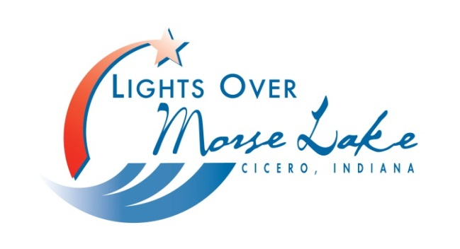
Sponsorship Form

Lights Over Morse Lake Festival
Cicero, Indiana
July 1-4, 2026
lightsovermorselake.org
Name (Business or Individual)
Contact Person
Full Address
Phone
Email
Website or Facebook page link

Signature | Date
Sponsorships for 2026: X = sponsorship fulfilled
Event Sponsors |  |  | Event Sponsors
 | Concert Sponsorships  2-$2500 Sponsor | $5,000 | X | Parade | $1,500
 | Thurs, July 2 – Stella Luna  Fri, July 3 – The Doo Band |  | X | Thursday Dog Show  Friday Dog Show  Saturday Dog Show | $1,500  $1,500  $1,500
 | Pickleball Blast | $1,000 | X | Golf Cart Poker Run | $1,000
X | Kids Day | $800 | X | Selah Grace 5K | $800
X | Golf Cart Scavenger Hunt | $500 | X | Car Show | $500
X | Talent Show | $500 | x | Music in the Park (1 needed) | $1,000
X | Golf Cart Decorating Contest | $500 |  | Anything under $500 will be listed as a Festival Sponsor

Please pay by PayPal, Venmo, or checks payable to:
Lights Over Morse Lake, Inc.
PO Box 854
Cicero, IN 46034-0854

Please label payment with your name/business
Lights Over Morse Lake Festival is a 501(c)(3), non for profit & donations are tax deductible. If you would like a tax receipt, please check here ____.

For more information, contact Jackie Hayden,
LOML President
317-446-1352 ● jbhayden20@gmail.com

SPONSORSHIPS

$5,000 & UP (Large Event Sponsor)
● 1/2-page ad in program (3,000 programs printed, over 20,000 social media views)
● Concert Sponsor Signage at Pavilion and Yard Signs around the Festival and Fireworks area
● Business banner displayed during Festival
● Free vendor booth space at Festival. We invite you to attend your sponsored event to promote your business
● Sponsorship listed on LOML website - business logo on the sponsor page with link to your website or Facebook
$1,500 LEVEL
● 1/2-page color ad in program (3,000 programs printed, over 20,000 social media views)
● Yard Signs around the Festival and Fireworks area
● Business banner displayed during Festival
● Free vendor booth space at Festival. We invite you to attend your sponsored event to promote your business
● Sponsorship listed on LOML website - business logo on the sponsor page with link to your website or Facebook
$1,000 - $800 LEVEL
● 1/2-page color ad in program (6,000-7,000 programs printed, over 20,000 social media views)
● Yard Signs around the Festival and Fireworks area
● Business banner displayed during Festival
● Sponsorship listed on LOML website - business logo on the sponsor page with link to your website or Facebook
$500 LEVEL
● 1/8-page color ad in program (6,000-7,000 programs printed, over 20,000 social media views)
● Logo displayed on our NEW centralized Event Information Sig
● Business banner displayed during Festival
● Sponsorship listed on LOML website - business logo on the sponsor page with link to your website or Facebook
Under $500 LEVEL
● Business or Individual’s name listed in program as a Festival Sponsor

